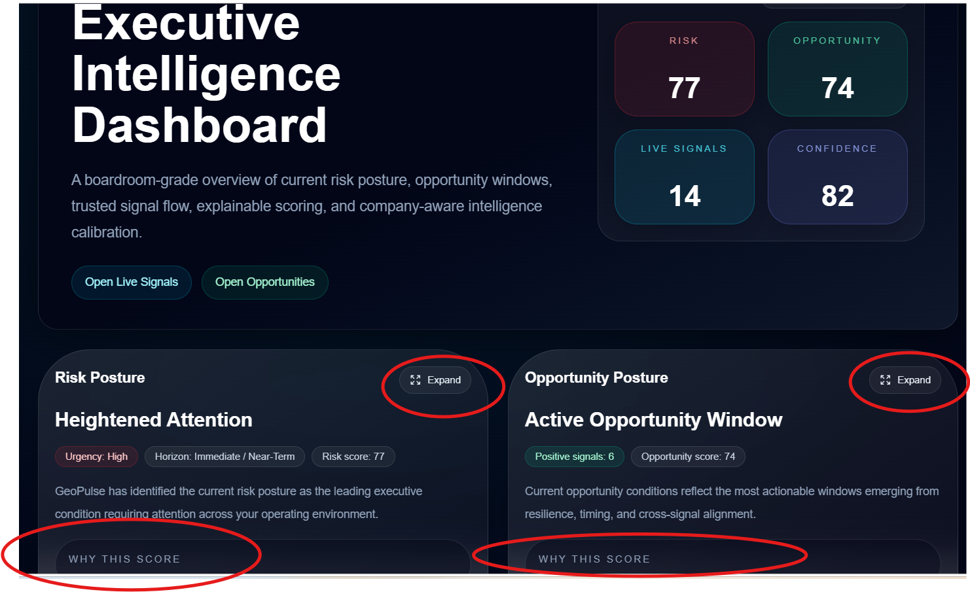
Issues circled in Red – Why this score , no actual feedback showing

Ris Exposure and Opportunity Exposure expand are not giving detail as per next screenshot
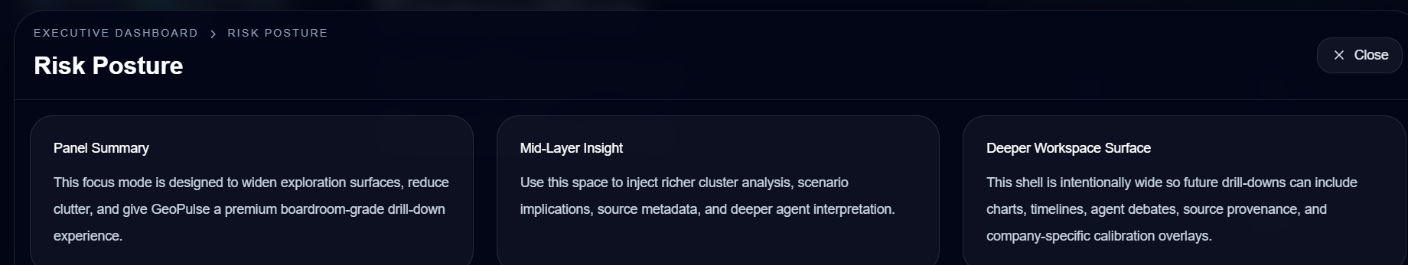

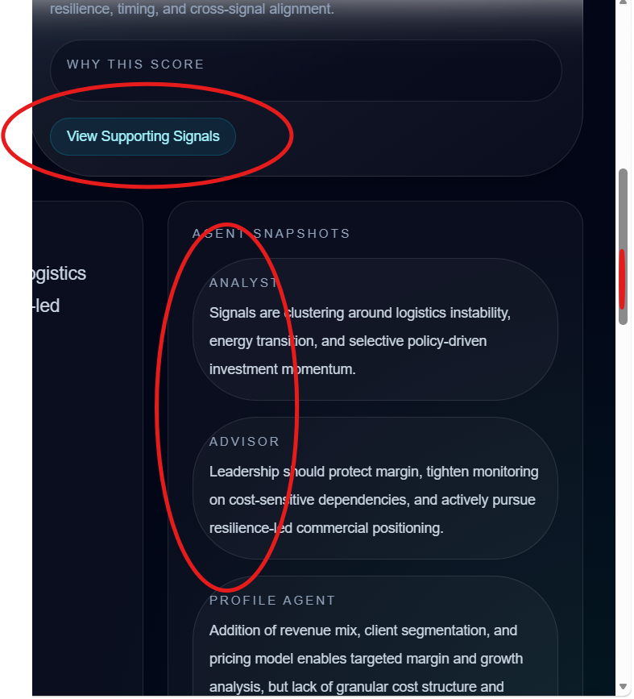
Analisst Advisor and Profile agebt Block need to be less rounded
View supporting signals button give the below limited genertic response, the same happens with risk supporting
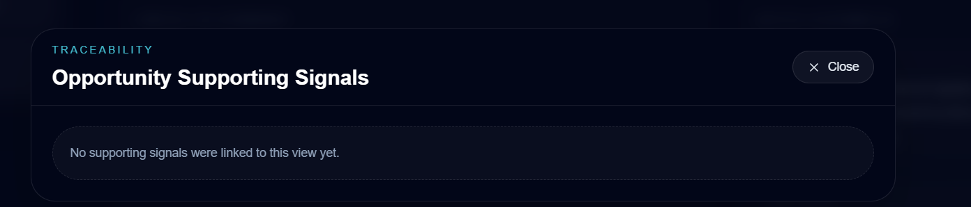

Next…
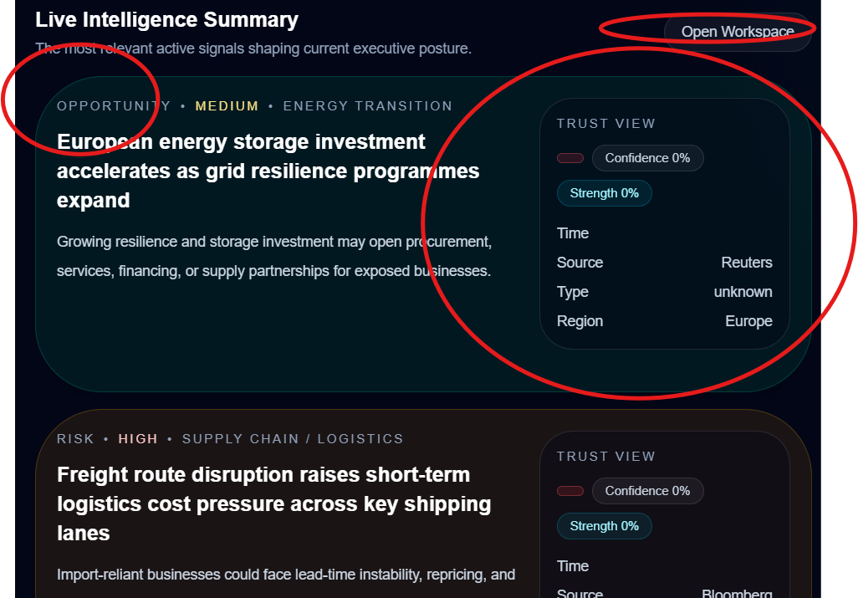
The Trust layer seems to be not reflecting ie Date Time, confidence etc

